[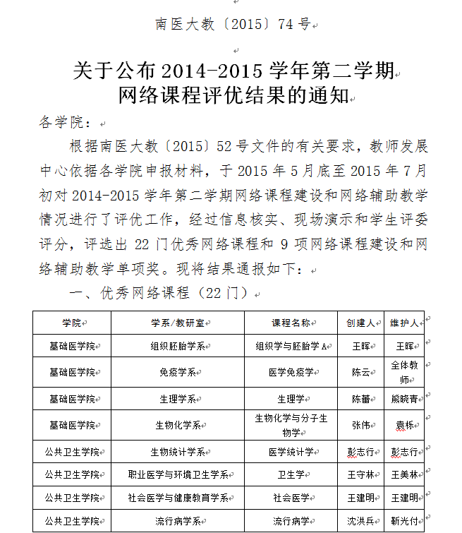](http://jsfzzx.njmu.edu.cn/_ueditor/dialogs/showOriginalImg.html?img=/_upload/article/89/65/32/794515e24ed482edb66a7fee1bda/7caaddd1-3b13-43e3-acc1-1e2fc35c5ff1_d.png)

[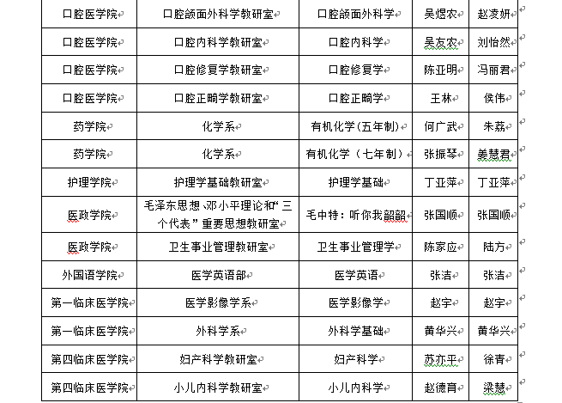](http://jsfzzx.njmu.edu.cn/_ueditor/dialogs/showOriginalImg.html?img=/_upload/article/89/65/32/794515e24ed482edb66a7fee1bda/56672da0-6762-4565-add0-b16a96a33199_d.png)

[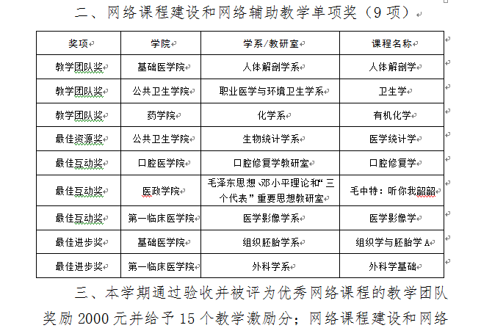](http://jsfzzx.njmu.edu.cn/_ueditor/dialogs/showOriginalImg.html?img=/_upload/article/89/65/32/794515e24ed482edb66a7fee1bda/e5fc1e03-2a25-451e-8288-ca0252d5b32b_d.png)

[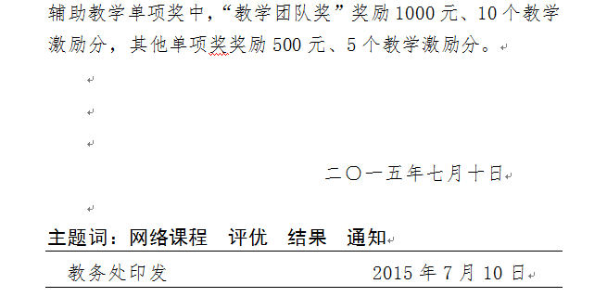](http://jsfzzx.njmu.edu.cn/_ueditor/dialogs/showOriginalImg.html?img=/_upload/article/89/65/32/794515e24ed482edb66a7fee1bda/26f3e38a-0de3-440a-b382-232a232b848b_d.png)